Hospitality and Tourism

Rebranded Theme Description

Mr. Bodenburg

**Rebranded Theme Description**

* What is your city’s theme/slogan?
* Describe the city’s champion, and why you chose it.
* What promise does your theme deliver?
* How will this theme deliver the promise?
* Show samples of your redesigned logo and theme.
  + Include coloring, lettering specifications…

EXAMPLE OF COLORING AND LETTERING SPECIFICATIONS:

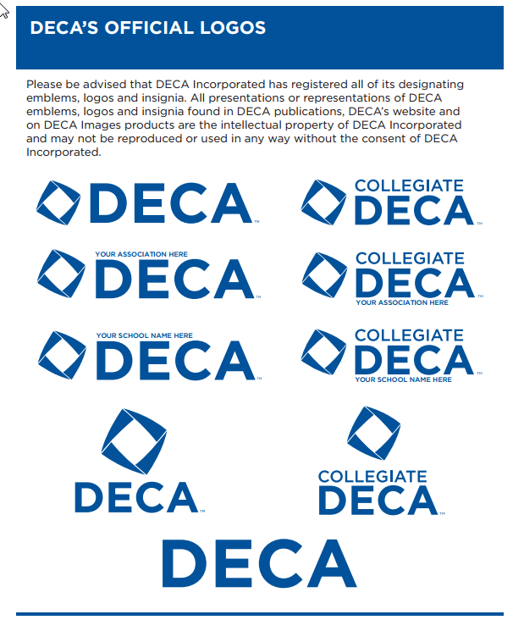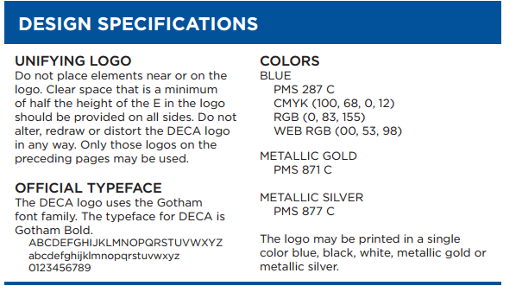

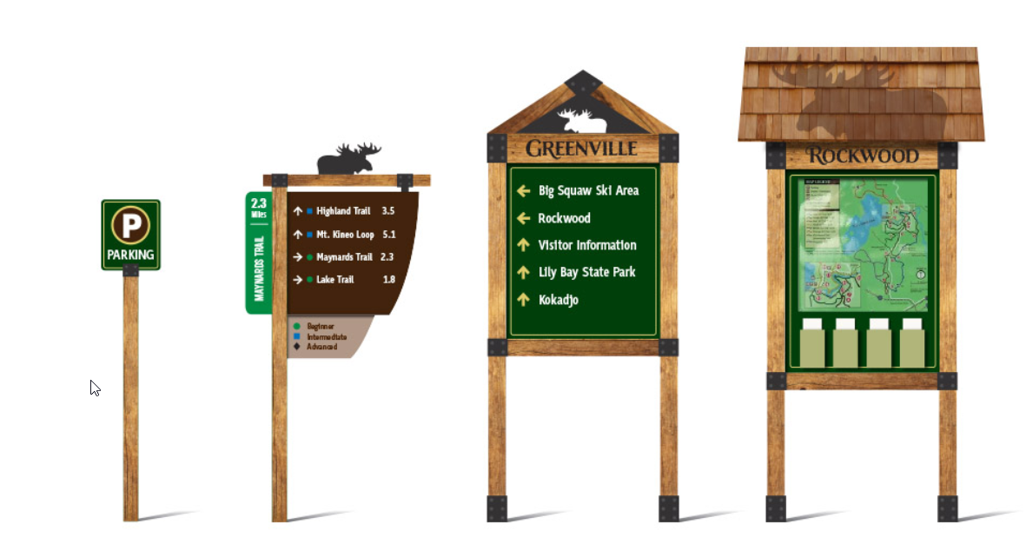SAMPLE EXAMPLES OF REDESIGNED LOGO AND THEME